Fragrance4u: An Interpretable Bodywash-to-Perfume Recommendation System

CMPE 255 – Data Mining

Authors:
Sankalp Wahane, Nikita Memane, Katherine Le
San José State University

Abstract
Choosing a perfume that aligns with personal scent preferences is a challenging and often costly task for consumers. While individuals can often identify fragrances they enjoy in everyday products such as bodywashes or soaps, translating these preferences into perfume selections is difficult due to limited fragrance literacy and the unstructured nature of scent descriptions. This project presents Fragrance4u, an interpretable data-mining–based recommendation system that identifies perfumes with fragrance profiles similar to familiar scented products.

The system leverages structured fragrance-note datasets and applies deterministic text normalization, synonym aliasing, and hybrid exact-plus-fuzzy token matching to compute similarity between product scent profiles. To reduce the dominance of vague descriptors, generic fragrance accords are penalized so that distinctive notes drive recommendations. Each recommendation is accompanied by a normalized match-strength score and an explicit explanation highlighting the matched fragrance notes, improving transparency and user trust.

The system produces analyst-friendly CSV and Excel outputs and includes a lightweight frontend application that enables interactive inference. Evaluation is performed through threshold sensitivity analysis, coverage metrics, and ablation studies comparing scoring strategies. Results indicate that penalizing generic accords improves recommendation quality and ranking clarity. Fragrance4u demonstrates that classical data-mining techniques—text preprocessing, similarity mining, and rule-based scoring—can deliver effective and interpretable recommendations without relying on large labeled datasets or black-box models.

1. Introduction

The global fragrance market offers an overwhelming number of perfume options, making selection difficult for consumers without specialized knowledge of fragrance notes or composition. Most consumers can identify scents they enjoy in everyday products such as soaps, shampoos, or bodywashes, yet struggle to map these preferences to perfumes. As a result, perfume purchases often involve costly trial-and-error and dissatisfaction.

This challenge can be framed as a data mining and similarity-matching problem. Fragrance descriptions are primarily text-based, inconsistent across brands, and frequently rely on generic descriptors such as fresh, woody, or citrus, which obscure meaningful differences. Traditional recommender systems in this domain often depend on user reviews, collaborative filtering, or proprietary chemical embeddings, limiting accessibility and interpretability.

Fragrance4u addresses this problem by focusing on content-based similarity mining using fragrance notes as structured features. The project emphasizes interpretability and auditability, allowing users and analysts to understand why a recommendation was made. The key contributions of this work include:
(1) a deterministic and explainable similarity-scoring framework for fragrance matching,
(2) an end-to-end pipeline integrating preprocessing, scoring, evaluation, and deployment, and
(3) an interactive demo that enables transparent inference without user history or labeled training data.

2. Related Work

Recommender systems have been extensively studied across domains such as document retrieval, e-commerce, and multimedia recommendation. Content-based recommenders rely on feature similarity rather than user interaction data and are particularly effective in cold-start scenarios. Prior research has explored token-based similarity, fuzzy string matching, and embedding-based semantic similarity for unstructured text comparison.

In fragrance recommendation, existing approaches frequently rely on collaborative filtering using user reviews or proprietary embeddings derived from chemical compositions. While embedding-based approaches capture latent semantic relationships, they tend to operate as black-box models and provide limited interpretability. Recent work in explainable recommendation systems highlights the importance of transparency, particularly for consumer-facing applications where trust and understanding are critical.

Fragrance4u aligns with classical data-mining approaches by emphasizing feature engineering, similarity mining, and explicit reasoning. Unlike black-box embedding models, the proposed approach provides clear, human-readable explanations for each recommendation, making it suitable for both end users and analysts.

3. Data
Three primary datasets are used in this project:
- Men’s Bodywash Dataset – Mens_Personal_Care_-_Keyword_Notes (CSV/XLSX)
- Women’s Bodywash Dataset – womens_bodywash_top100_with_notes_only (CSV/XLSX)
- Perfume Catalog Dataset – final_perfume_data.xlsx

The perfume catalog contains the following expected columns, which are auto-detected heuristically during ingestion:
- Product or perfume name
- Fragrance notes (free-text string of accords or ingredients)
- Brand (optional)
- Image URL (optional, used for UI rendering)

All datasets contain unstructured textual descriptions of fragrance notes with inconsistent formatting, synonyms, and filler terminology. Preprocessing is therefore a critical step in ensuring meaningful similarity computation.

4. Methodology

4.1 Normalization and Tokenization

Each fragrance description is normalized by converting text to lowercase, removing parenthetical content, and standardizing punctuation. Strings are split using common delimiters such as commas, semicolons, and conjunctions. Filler terms including note, accord, essence, extract, and structural descriptors such as top, middle, and base are removed.

A curated alias map is applied to unify synonymous terms (e.g., orange blossom → neroli, oud → agarwood, vanilla bean → vanilla). Tokens are deduplicated per product while preserving their original order.

4.2 Candidate Pruning

To avoid exhaustive comparisons between all bodywashes and perfumes, all perfume notes are pre-tokenized and indexed using inverted indices over both full tokens and token substrings of sufficient length. For each bodywash, only perfumes sharing at least one token or token substring are retrieved as candidates, significantly reducing computational overhead.

4.3 Similarity Scoring
Similarity is computed using a hybrid matching strategy. Exact token matches receive full weight, while fuzzy matches—determined using string similarity thresholds or substring containment—receive partial weight. Tokens that do not meet either criterion are ignored.
Generic fragrance accords such as woody, floral, fresh, and citrus are down-weighted using a multiplicative penalty to reduce their influence. A greedy one-to-one pairing strategy ensures that each perfume token is matched at most once. The final similarity score is normalized by the number of bodywash tokens, yielding a match-strength score between 0 and 100.

4.4 Recommendation and Explanation

For each bodywash, the perfume with the highest match-strength score is selected as the recommendation. Explanations are generated by storing matched note pairs along with their match type (exact or fuzzy), enabling transparent reasoning.

5. System Architecture

The system follows a modular pipeline: Inputs → Preprocessing → Indexing → Matching → Metadata Join → Outputs/UI. Outputs include CSV and Excel reports for offline analysis and a lightweight HTML/React-based frontend that enables interactive inference with image and explanation display.

6. Experiments and Results

To evaluate the effectiveness of the proposed recommendation system, multiple experiments were conducted focusing on score behavior, coverage, and the impact of scoring components.

Figure 1 presents the distribution of normalized match-strength scores across all bodywash–perfume recommendations.
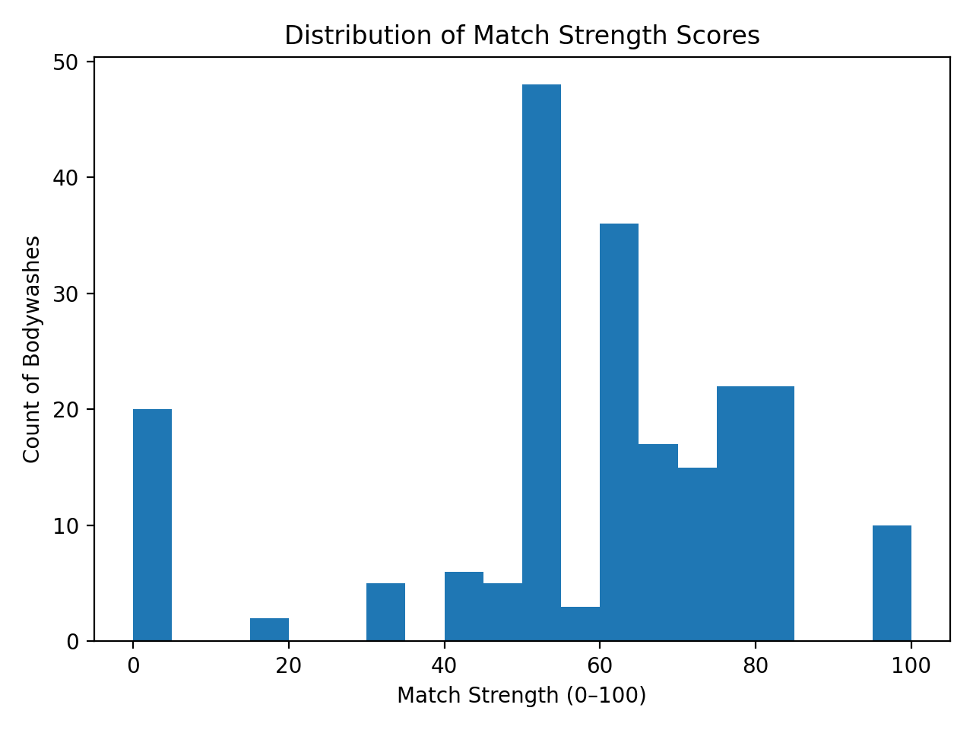
[Figure 1: Match Strength Distribution]

The distribution shows a clear separation between low-confidence and high-confidence matches, indicating that the scoring function effectively discriminates between strong and weak scent similarities.

To analyze system sensitivity, a threshold-based coverage experiment was conducted. Figure 2 illustrates how the proportion of bodywashes receiving recommendations changes as the minimum match-strength threshold increases.

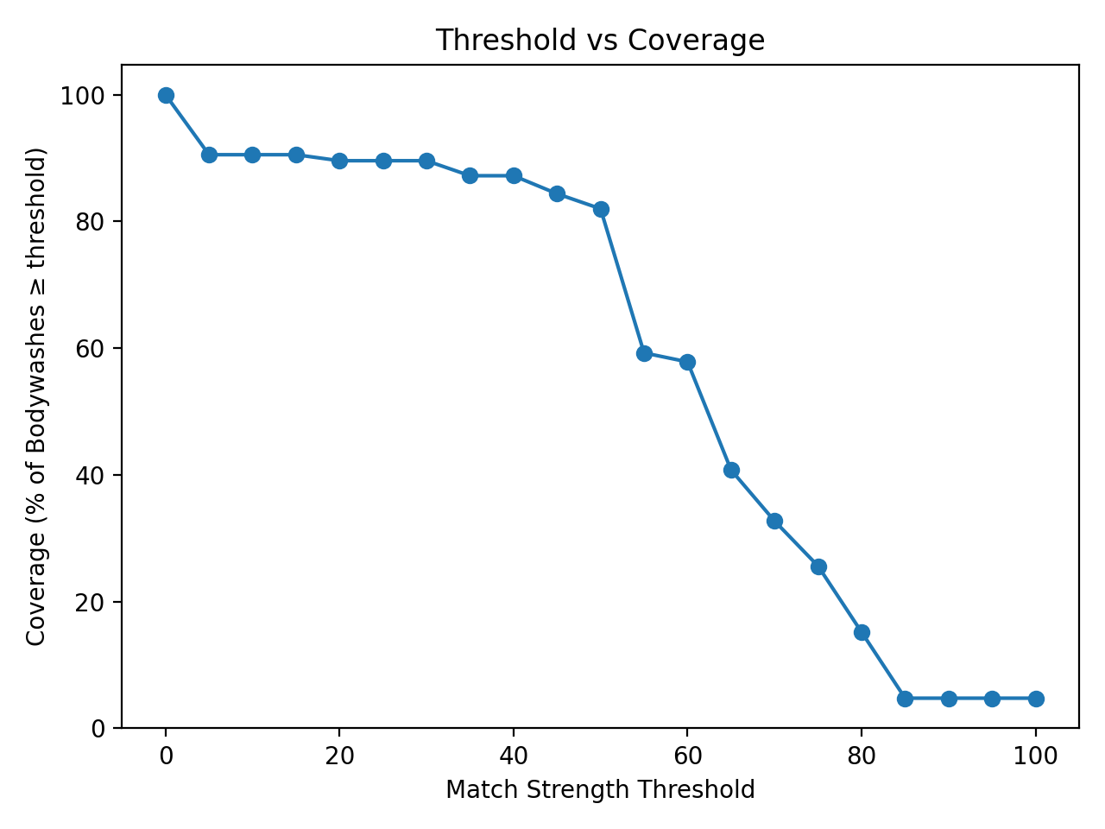
[Figure 2: Threshold vs Coverage]

As expected, coverage decreases as the threshold increases, highlighting the trade-off between recommendation confidence and breadth.
An ablation study was performed to evaluate the impact of penalizing generic fragrance accords. Figure 3 compares similarity scores computed with and without generic-accord penalization.

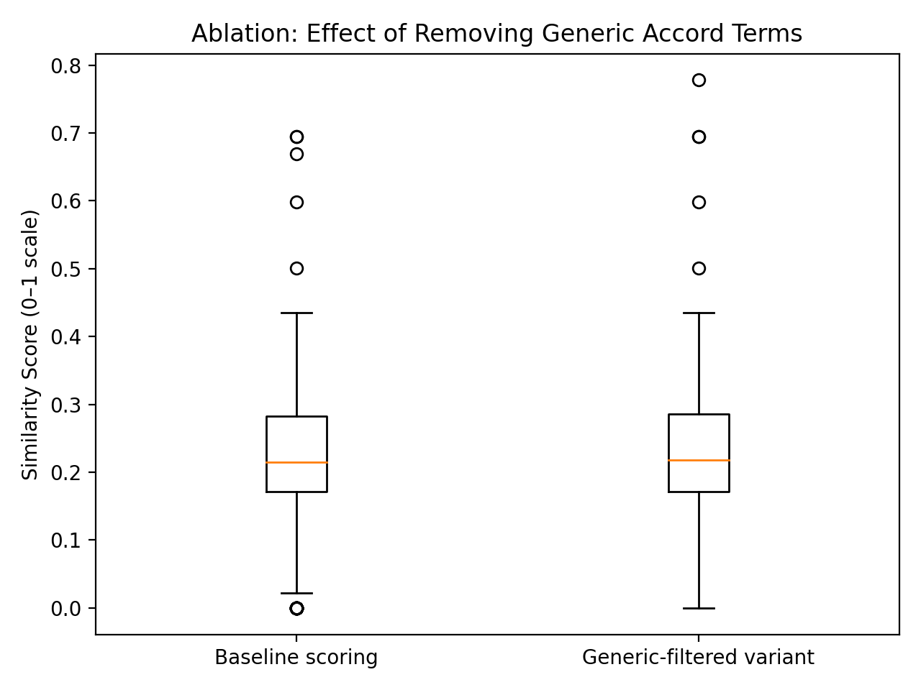
[Figure 3 here: Generic Penalty Ablation]

The penalized variant produces more discriminative scores, confirming that down-weighting generic descriptors improves recommendation quality.

7. Evaluation Metrics and Visualizations

Evaluation focuses on normalized match-strength scores, recommendation coverage, and qualitative alignment with human intuition. The match-strength distribution (Figure 1) provides insight into score calibration, while the threshold–coverage curve (Figure 2) demonstrates system sensitivity to confidence cutoffs. The ablation comparison (Figure 3) highlights the contribution of generic-accord penalization to overall recommendation quality.

The visualizations referenced in this section are stored in the visuals/ directory of the project repository as:
- fig1_match_strength_distribution.png
- fig2_threshold_vs_coverage.png
- fig3_generic_penalty_ablation.png

8. CRISP-DM Methodology

The project adheres to the CRISP-DM framework. Business understanding focuses on assisting consumers in fragrance discovery. Data understanding and preparation address inconsistent textual descriptors. Modeling applies deterministic similarity scoring, evaluation uses quantitative and qualitative analyses, and deployment delivers results through files and an interactive frontend.

9. Limitations

The system relies on textual fragrance descriptions and cannot fully capture nuanced olfactory perception. Performance depends on dataset completeness and descriptor quality, and some semantic equivalences remain approximated despite aliasing.

10. Future Work

Future extensions include embedding-based semantic similarity, learning-to-rank approaches using user feedback, diversification strategies to reduce repetitive recommendations, and backend integration for real-time inference.

11. Conclusion

Fragrance4u demonstrates that interpretable data-mining techniques can effectively address a real-world recommendation problem. By prioritizing transparency, careful preprocessing, and evaluation-driven design, the system delivers meaningful perfume recommendations without relying on opaque models or extensive labeled data.

Appendix A: Key Parameters and Reproducibility Details
- Fuzzy similarity threshold: 0.86
- Exact match weight: 1.0
- Fuzzy match weight: 0.8
- Generic accord penalty multiplier: 0.35

Generic fragrance accords include citrus, floral, woody, musky, fresh, spicy, fruity, green, powdery, warm, aquatic, marine, soapy, and clean. All experiments can be reproduced using the provided Python script and documented notebook included in the project repository.

References -

